2012 HCI H2 Math Prelim Paper 1 Marking Scheme

Qn. | Solutions
1 | 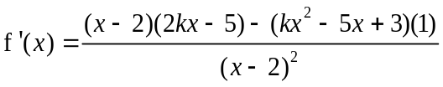  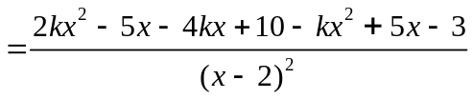  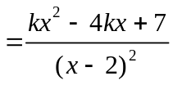  Since f is an increasing function,  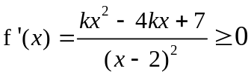  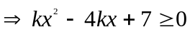 for all values of x  Hence we have 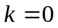 (linear) or  for 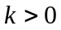, 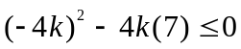 (quadratic)  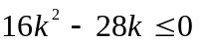  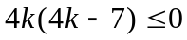  Hence 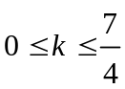.
2 (i) and (ii) | 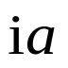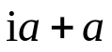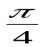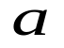  M  O  Re  Im  Locus of z  B  A  C  Q
 | 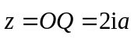
3 | 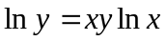  Differentiate implicitly w.r.t x,  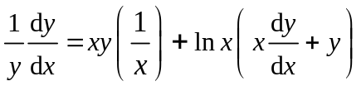  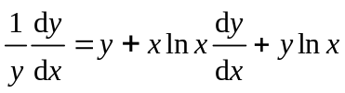  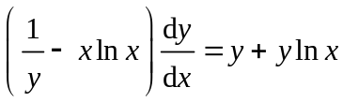  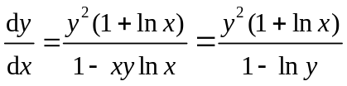  For the tangent to be parallel to the y–axis, 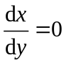  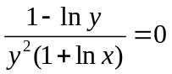  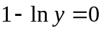  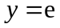  Hence from 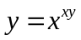, we have 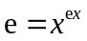  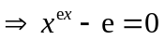  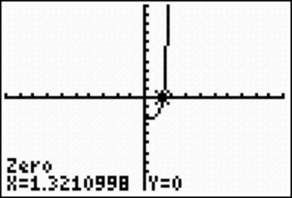  Hence x = 1.32, and since the tangent parallel to the  y–axis takes the form , hence equation of tangent is 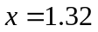
4(a) | 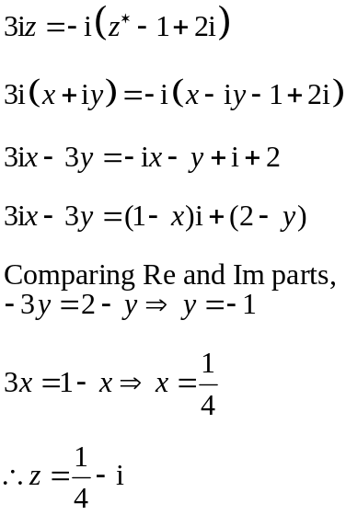
(b) | 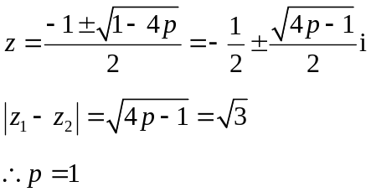
5(i) | 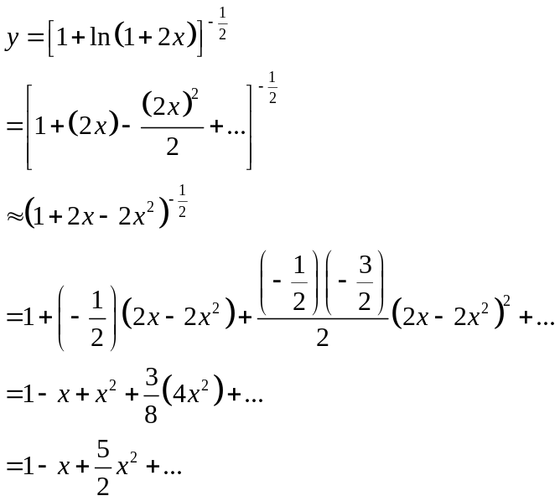
(ii) | 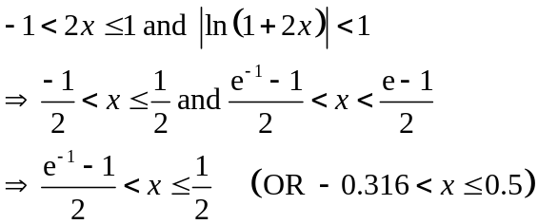
(iii) | 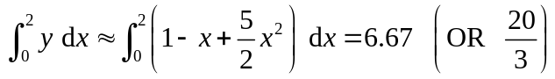  Since the integration in 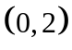 does not fall into the valid range of , the approximation is not good.
6(a) | Assume the x th day to be the day with maximum amount of goods delivered.  For the first x days:  ( a = 1000, d = 100)  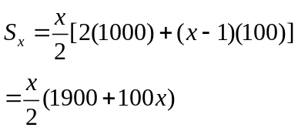  For the remaining (15- x) days:  ( a = 1000+ (x - 1)100 – 100 = 800+100x, d = -100)  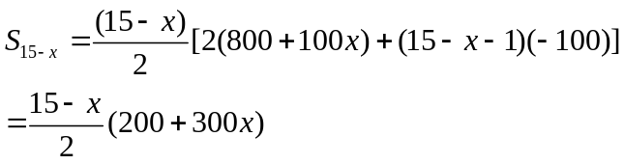  Since total goods delivered is 21300 tons,  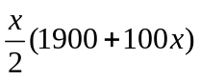+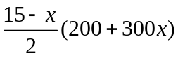= 21300  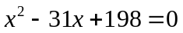  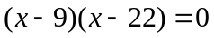  x = 9 or x = 22 (NA, since x 15)  Therefore, 9th June was the day with max goods delivered.  Goods delivered = 1000 + (91)(100) = 1800 tons
(b)  (i) | Series H is a GP with common ratio r.  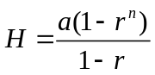 or 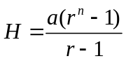  C is a GP with common ratio 1/r.  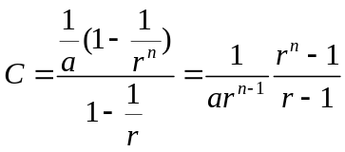  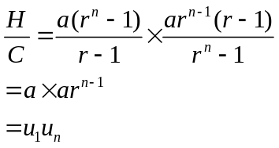
(b)  (ii) | 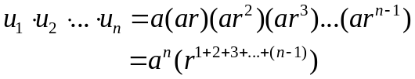  =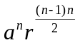  Since 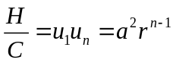,  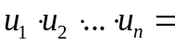  = 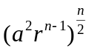 = 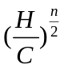
7(a) | 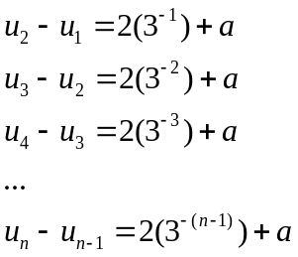  Sum of all equations:  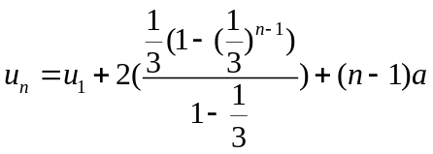  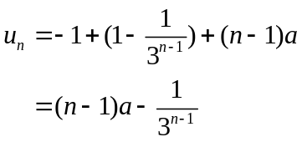
(b) | Let 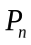 be the statement denoting  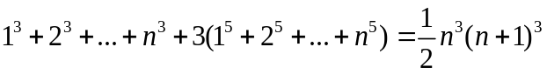for 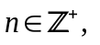  When n = 1,  LHS = 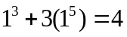  RHS = 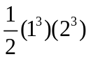= 4 =LHS  Therefore, is true.  Assume 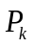 is true for some values of 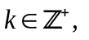i.e.  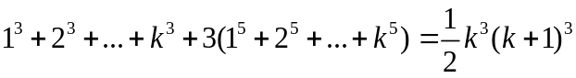  To prove 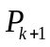, i. e.  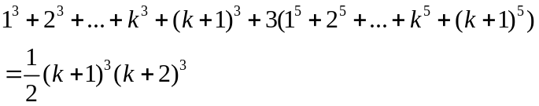  LHS =  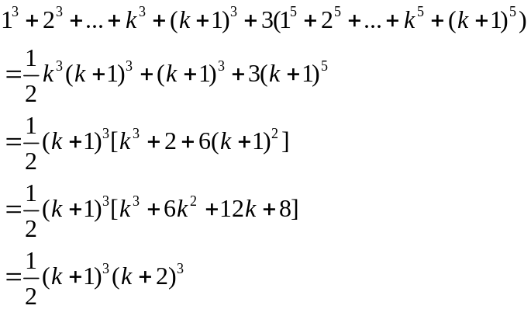  =RHS  Therefore is true.  Since is true, 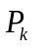 is true 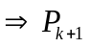 is true. By mathematical induction, is true for all 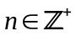.  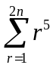=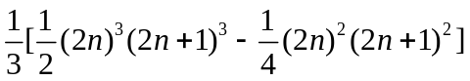  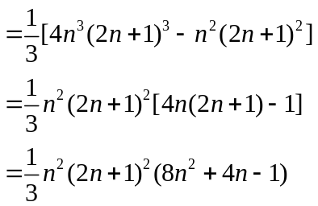
8(i) | 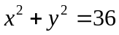
(ii) | 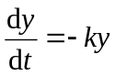  Method 1  Implicit Differentiation w.r.t. time  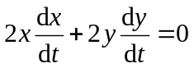  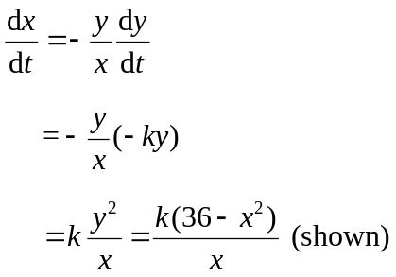  Method 2  Implicit Differentiation w.r.t  then using chain rule (rate of change equation)  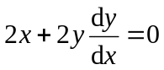  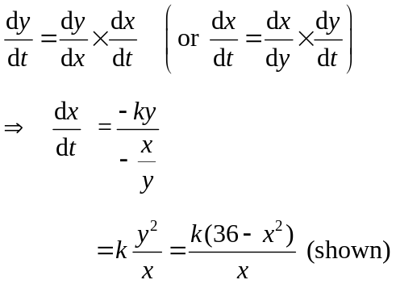
(iii) | 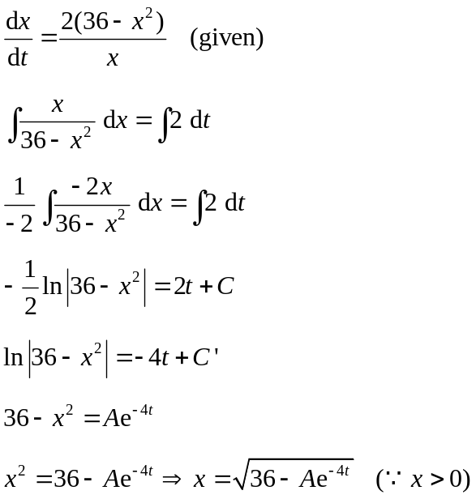  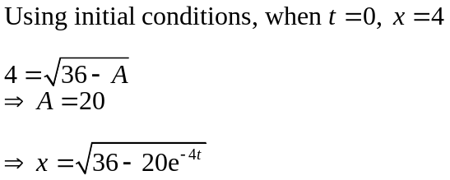  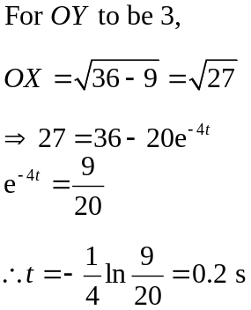
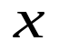      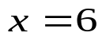  (iv) | 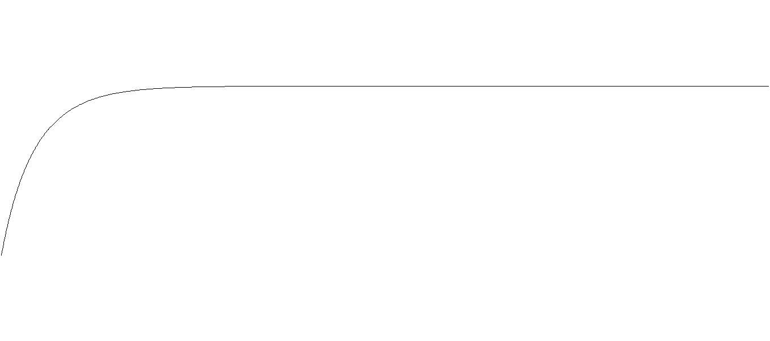  Jesse’s model is not appropriate.  Based on Jesse’s model, the rod would never fall flat on the ground.
9  (i) | 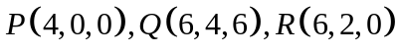  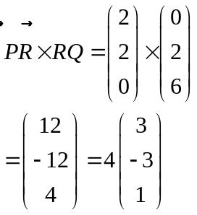  So the equation of the plane is  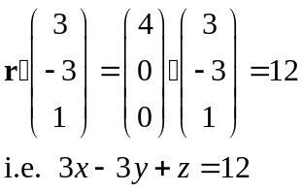
(ii) | Method 1  the length of projection of  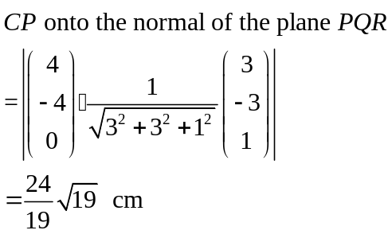  = 5.51 cm (correct to 3 sig figs)  Method 2  Denote the foot of perpendicular of C to the plane PQR as N. Then 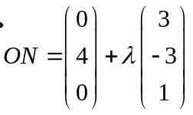  Sub into the equation of plane PQR,  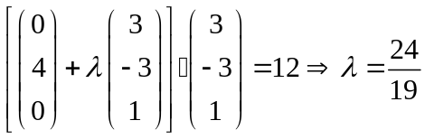  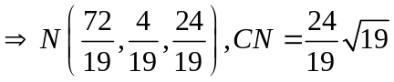 or 5.51 cm
(iii) | 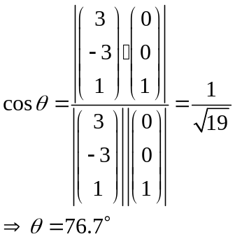
(iv) | Line PQ: 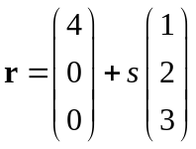, Plane OCGD:   At point M, 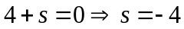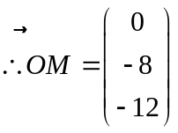  The distance from M to the plane OABC is 12 cm
(v) | 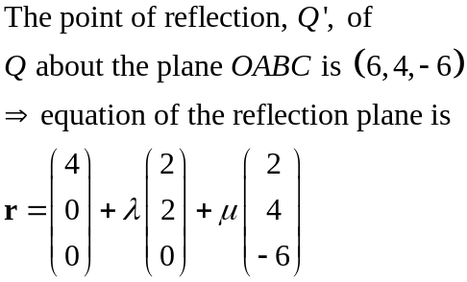  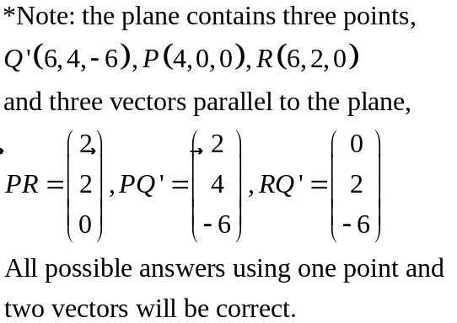
10  (a)  (i) | 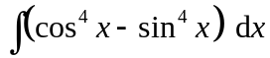  = 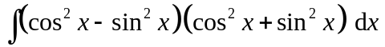  = 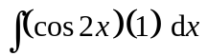  = 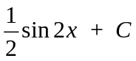
(ii) | 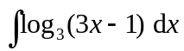  = 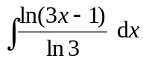  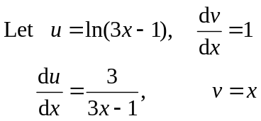  = 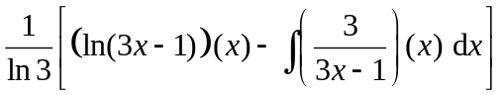  = 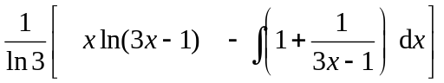  = 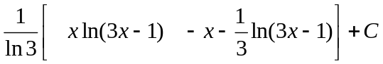  = 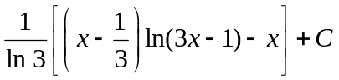
(b) | 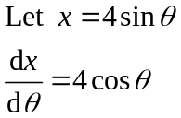  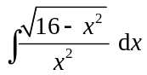  = 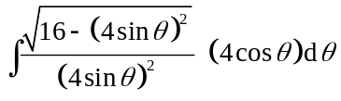  = 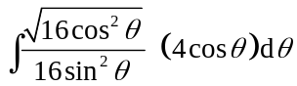  = 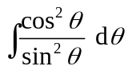  = 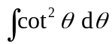  = 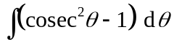  = 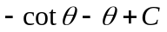  Now, 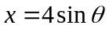,  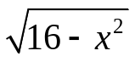  ∴ 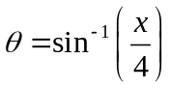  x  4  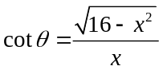  ∴  = 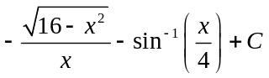 (shown)
11  (a)  (i) | 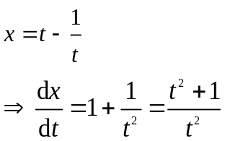  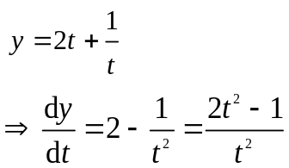  Hence  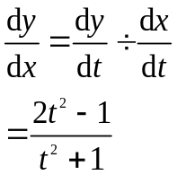  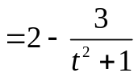  Hence we have  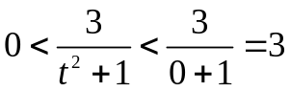  Hence 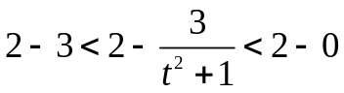  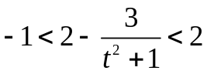 (shown)
(a)  (ii) | 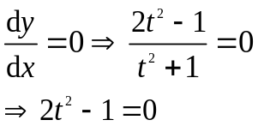  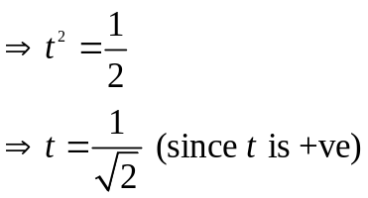  At 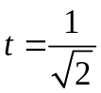,  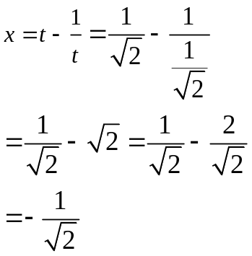
(iii) | At x = 0, t = 1 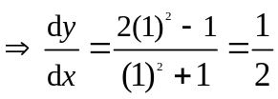  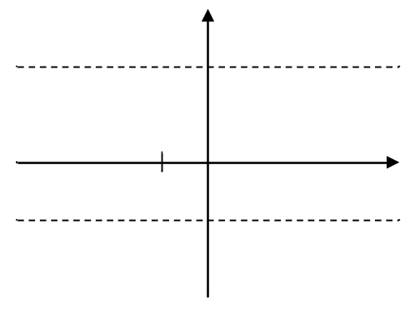
(b) | 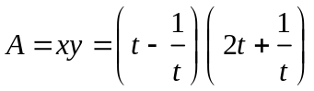  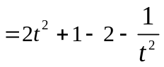  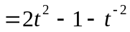  We have 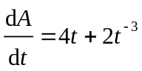  When 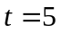  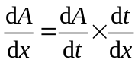  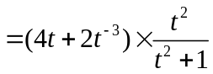  = 19.2

